**INTERNATIONAL COMMISSION FOR THE CONSERVATION OF ATLANTIC TUNAS**

**COMMISSION INTERNATIONALE POUR LA CONSERVATION DES THONIDES DE L´ATLANTIQUE**

**COMISION INTERNACIONAL PARA LA CONSERVACION**

**DEL ATUN ATLANTICO**



**ASSESSMENT PROGRAM DOCUMENTATION**

**Program: SEEPA (vers. 3.0)**

Simulates longline catch and effort data.

# Current Catalog Entry: November 2004 First Cataloged by ICCAT:

**Catalog Committee**

**External:** Jaime Mejuto (IEO, Spain)

Yukio Takeuchi (NRIFSF, Japan) Elizabeth Babcock (Univ. Miami, USA)

**ICCAT Secretariat:** Victor Restrepo

NOTE: As part of its efforts to carry out Quality Management, ICCAT´s Standing Committee on Research and Statistics is developing a catalog of stock assessment applications. The purpose of the catalog is not to evaluate the relative merits of various assessment methods, but rather whether the software implementing the method works as intended and is adequately documented.

# PROGRAM NAME

SEEPA

# VERSION (DATE)

Version 3.00, dated April 2003

# LANGUAGE

VISUAL BASIC 6

# PROGRAMMER / CONTACT PERSON

C. Phillip Goodyear 1214 N Lakeshore Drive

Niceville, FL 32578, USA [philgoodyear@cox.net](mailto:philgoodyear@cox.net)

# DISTRIBUTION LIMITATIONS

Only executable code can routinely be distributed, along with the users manual and sample files. However, source code is available from the author upon written request and with agreement to certain restrictions. The executable program files are large. Users should contact the author to obtain them.

# COMPILER NEEDS / STAND-ALONE

The program does not require other software, except an operating system for examination of the robustness of habitat standardizations. However, some features require population simulations produced by FSIM. Also, comparisons of the habitat-standardization results to the results of other standardization methods will require access to other software to accomplish those analyses. A good ASCII file editor is also recommended. Some of the graphics require either 1024x768 or 1280x1024 pixel resolution for best results. The program is presently available from author for 32-bit Windows. It was developed on a Windows 2000 platform and should also work with Windows 9x, Windows ME, Windows NT, and Windows XP.

# PURPOSE

This program simulates longline catch and effort data to test the robustness of the habitat approach to cpue standardization. It could also be used to develop simulated datasets to test other approaches to summarizing and standardizing longline cpue.

# DESCRIPTION

**Program overview**

The program integrates an assumed species distribution with assumed gear deployments in time, space, and patterns of the depth distributions of hooks to develop time series of simulated cpue. The program includes modules to manipulate most of the input data series. Included among these are the species distribution patterns in time and space, the average depths of longline hooks and the distributions around the means, some aspects of hook movement, and the species affinity to take moving baits. In addition to the data simulator, the program has a module to make habitat-corrected estimates of the simulated data sets. The computer program used to implement the simulator is designed to allow interactive manipulations of many of the important variables involved in the simulations, and necessarily involves a number of data files and programs as presented schematically in Figure 1.

# Habitat

The physical dimensions of the habitat correspond to the Atlantic Ocean from 45° S to 55° N latitude divided into cells of 1° latitude by 1° longitude and 10 depth layers. The depth layers are 0-20m, 20-50m, 50-100m, 100-150m, 150-200m, 200-250m, 250-300m, 300-400m, 400-500m

and 500-600m. Applications of the method have used monthly analyzed temperature data for the Atlantic Ocean that were obtained from NOAA NODC World Ocean Atlas 1998 (Conkright et al.1998) and these data are distributed with the program in the file, **Atlantic98_temp.tdf**. Mean temperature for each of the 10 depth layers is a simple mean of appropriate depth interval values from the World Ocean Atlas. Temperature varies by month, but not by year. Temperature values for latitude-longitude-depth cells that are below the ocean floor are assigned negative numbers, and all latitude-longitude-depth cells with negative temperatures are excluded from the simulations. Volumes of all cells are corrected for latitude. No adjustment was made to diminish the volume of any cell that contains the sea floor.

# Species data

SEEPA provides for both a species of interest and a single target species for the simulated fishery. Target species abundance is not modeled, only its (monthly) spatiotemporal distribution within a year. SEEPA reads monthly abundances by sex and age from an FSIM (Goodyear 1989) output file. It then summarizes the data into a maximum of 4 sex-age groupings that can have different environmental affinities, and hence different temporal and geographical distributions. Alternatively the SEEPA may be used to generate a simple population trend to be used in the cpue simulations.

The simulated spatiotemporal distributions of the species can be derived externally, for example from observed distributions of cpue, or from a relationship that maps relative abundance to an environmental variable. If this distribution is produced by SEEPA, the relative concentration of the species is assumed to be a function of temperature. This shape of the function can be manipulated interactively using SEEPA’s environmental affinity editor.

The species relative distribution is given by:

*P*  *Ag* ,*tTl* ,*n*,*d* ,*mVl* ,*n*,*d* ,

 *g* ,*t*

*l* ,*n*,*d* ,*m*

*l* ,*n*,*d*

(1)

*g* ,*l* ,*n*,*d* ,*m*

where:

*A T V*

*L*,*N* ,*D*

*Pg,l,n,d,m =* proportion of species group *g*, at latitude *l*, longitude *n*, and depth layer *d*, in month *m; Ag,t=* relative concentration (affinity) of group *g* at temperature *T* (° C);

*Tl,,n,g,m =*average temperatur*e* (° C) at latitude *l*, longitude *n*, and depth layer *d* in month *m*; and

*Vl,,n,d,* = relative volume at latitude *l*, longitude *n*, and depth layer *d.*

The absolute distribution of the species groups for each month of each year is the product of the *Pg,l,n,d,m* and the monthly total species-group abundances *Ng* summed from a population abundance time series.

SEEPA also allows catchability to vary with hook velocity. The function implementing this feature is a simple scalar for the velocity effect (*β*) which varies from 0.0 to 1.0 over an arbitrary, user specified, range of velocities.

# Gear

The longline is represented by a single “basket” of gear which is a section of gear from one float to the next. The number of hooks per basket (hpb) has been routinely employed in cpue standardizations of the Japanese longline gear in the Atlantic (Anon. 2001). The explicit physical

attributes simulated include the number of hooks between floats, the length of the float line, the length of the mainline and the length of the branch line inclusive of all terminal gear. Branch lines are assumed to be equally spaced along the mainline. Other variables include, the soak duration, and initial and equilibrium shortening rates (the ratio of the distance between floats and the length of the mainline between them), the time required for the basket of gear to sink to an initial shortening rate, and the length of time required for the gear to assume an equilibrium shortening rate. The amount of time and velocity of each hook in each layer of the water column as it initially sinks is computed assuming a constant rate of fall from the surface until the gear assumes its initial shortening rate. Hook depth at the end of the initial sink is estimated from a catenary curve assuming the initial shortening rate and that the mainline is suspended from the bottom of the float line, directly below the float. If the equilibrium shortening rate is smaller than its initial rate then the time and velocity of each hook in each layer of the water column is updated assuming the transition from the initial to equilibrium condition occurs at a constant rate. Hooks are assumed to have zero velocity once the equilibrium is reached and before retrieval begins. These velocities are used to modify catch rates species is assumed to have a propensity to bite moving baits. It is assumed that when the gear is retrieved it undergoes the same process as when initially deployed, only in reverse. The result is a matrix with of the amount of time each hook spends in each depth layer for a particular longline configuration. These are further modified by a specified distribution of hook fishing depths about the values expected from the catenary. The configuration of each simulated gear is not varied by where or when the gear is deployed. However, up to 10 unique simulated configurations can be employed and their proportions of the total effort can vary by year. Bait movement as a result of ocean currents, or that might be caused by other fish on the longline are not included. In addition, no attempt is made to model gear saturation caused by other species on the longline.

The proportion of total longline sets made with each gear configuration each year is determined by specifying annual gear deployment probabilities. These gear deployment probabilities can be can be interactively modified to explore implications of particular pattern.

# CPUE Simulations

The simulations that develop the time stream of cpue estimates proceed sequentially by month from the first to the last year to be simulated. A specified number of longline sets are sampled each month. The latitude and longitude for each set is picked randomly from the available cells, but may be weighted by the simulated abundance, observed cpue, or effort for of the species of interest or a target of the fishery. Once the latitude and longitude of the set has been determined the gear to be deployed is randomly selected based on that year’s gear-deployment probability distribution. The cpue may be calculated either as the mean for each hook-depth for the average basket of gear, or based on integer catches as the sum of simulated numbers caught divided by the number of hooks set.

*Mean CPUE* **–** Catch by hook and depth for each species age-sex group (*Cg,h,d*) is then computed for each depth fished by each hook as:

*Cg*,*h*,*d* ,*c*

(2)

where,

 *qNy*,*m*,*gWg*,*h*,*d* ,*c Pg*,*l*,*n*,*d* ,*m* ,

*q* = catchability

*Ny,m* = Population number in year *y* and month *m*, and

*Wg,h,,d,c* = weighted bite probability for species age-sex group *g,* hook *h,* in depth *d*, on longline configuration *c*.

*Wg*,*h*,*d* ,*c*

 *v*,*gV*1,*c*,*h*,*dT*1,*c*,*h*,*d*

* *v*,*gV*2,*c*,*g*,*h*,*dT*2,*c*,*h*,*d*

*T*3,*c*,*h*,*d*

# (3)

*βv,g* =catchability multiplier for species age-sex group *g* bait velocity *V,*

*V1,c,h,d and T1,c,h,d=* Average velocity and length of time that hook *h* is present in depth *d*

during the period that gear configuration *c* is initially sinking;

*V2,c,h,d and T1,c,h,d =* Average velocity and length of time that hook *h* is present in depth *d* during the period the gear is transitioning to the equilibrium shortening rate for the set for gear configuration *c*;

*T3,c,h,d =* Length of time hook *h* is present at depth *d* while gear configuration *c* is settled. If the simulation specifies a distribution of hook fishing depths about the values expected from the catenary, then the *Wg,h,,d,c* for each set is estimated for the ith quantile of the specified distribution, drawn at random in proportion to its contribution to the

cumulative frequency of the distribution.

Note that absent the velocity effect, catchability is assumed to be a constant (1.0) multiple of time. In the simulation, the sampling does not influence fish abundance (no removals), there is no sampling error, and the cpue by hook for each set where marlin are present catches some fraction of the population present. Specifically, the catch per hook is a fraction for each hook, and not a series of 0’s and 1’s.

*Integer catches* **–** If the user specifies this option, the catch on each hook of a set is simulated determined to be either present (1) or absent (0). The computation is identical to equation 2 except that the resulting value is compared to a uniform random number. If the cpue is greater than the number drawn the hook catch is set to 1. If not, it is set to 0. This is repeated for each simulated hook on the longline, and the cpue for the set is simply the ratio of number of individuals caught to the number of hooks set. Note that with this scheme, the probability of a fish being taken is proportional to N, so that the user must specify a value for q that gives numbers caught per set that are reasonable for the analysis being conducted.

# Analyses of simulated CPUE data

SEEPA provides for 3 types of analyses. First is a simple trend of the unstandardized CPUE along with the trend in the true abundance of the species, and the true abundance in those latitude-longitude-month cells sampled. Second, is the average cpue at each hook position relative to the floats. This analysis provides a basis for comparison to similar observations from the fishery. The third type of analysis produces a habitat corrected cpue trend. The annual habitat-standardized relative abundance estimates can be computed in two ways.

*Mean cpue at depth* **–** If the simulated cpue are based on the **mean cpue** simulation option (which saves catch rates in each depth layer), then the habitat standardization can be computed as the annual means over all sets and species sex-age groups of:

^

*Ng*,*l* ,*n*,*d* ,*m*   ^

*Og*,*h*,*d* ,*c*

^ ,

(4)

where:

^

*Wg*,*h*,*d* ,*c Pg*,*l* ,*n*,*d* ,*m*

*N g* ,*l* ,*n*,*d* ,*m* = estimated abundance of species sex-age group *g*; at latitude *l*, longitude *n*, depth layer *d* in month *m*;

*Og* ,*h*,*d* ,*c*

= Observed (simulated) catch of species group *g*, on hook *h* in depth layer

*d* for longline configuration *c*.

^

*W g* ,*h*,*d* ,*c*

= estimated weighted bite probability of species group g, on hook h, in

depth layer d for longline configuration c;

^

*Pg* ,*l* ,*n*,*d* ,*m* = estimated proportion of species group *g*, at latitude *l*, longitude *n*, and

depth layer *d*, in month *m*, and;

^ ^

Note that in this formulation, if the *W* , *P* , and *O* are known without error then each estimate of

^

*N* from this relationship is the same; i.e., the local abundance in the area sampled is corrected

by the proportion of the population in that area and will estimate the value of *qN*. In the context of simulated data, these values are known because they are used to simulate the observed time series of cpue, and when employed in the habitat standardization will exactly reproduce the true abundance time series.

*Catch/effective effort* - The habitat-standardized cpue for each set is computed by dividing the observed (simulated) catch (*C*) by an estimate of effective effort (*E*) for the set:

*cpue* *C E*

. (5)

Effective effort (*E*) for each set is estimated as:

^ ^

*E*  

*H*

 *Wg*,*h*,*d* ,*c Pg*,*l* ,*n*,*d* ,*m* , (6)

*D*

where the depths for the *Wg,h,,d,c* are predicted from the catenary or the values corresponding to the actual means of the distribution of depths for each hook. The annual means of the habitat- standardized cpue are estimated by averaging these values over all sets per year. *Wg,h,,d,c*.

^ ^

In the real world, *W* and *P* must be estimated externally from some source of information for

every gear configuration deployed in the history of the fishery, and are very unlikely to be accurate. The robustness of the habitat standardization method can be tested by substituting

^ ^

alternative assumptions about *W* and *P* .

The **mean cpue at depth** method is useful to test the implications of alternative assumptions, but can only be applied if the **Mean cpue simulation** option is selected for the simulation. It is probably impossible to actually gather the data required to apply this approach to real observations because, among other things, it requires estimation of the actual depth at which each fish is caught on every set. In SEEPA, the **catch/effective effort** is designated the “standard method” for analyses. The output from both forms of analyses is a habitat-standardized trend in cpue along with 95% confidence intervals. Also, if desired, the habitat-standardized cpue for each set can be saved.

# REQUIRED INPUTS

**Environment**

SEEPA requires the spatiotemporal distribution of temperature which is read from a file with an

*.tdf extension. This file must be created external to SEEPA, and a sample Visual Basic 6 program format_temp.vbp, is provided as a guide to creating these files. Also the relative volume by latitude is read from a file with an *.llv extension. The relative volume file distributed with SEEPA (“LonLat volume wts.llv”) computes the relative surface area of a degree square as the cosine(latitude), which is the default value if no relative volume file is specified.

# Population trends

The population trend with time is not simulated but rather read from a file. That file can be generated using the fish population simulator, FSIM [a more recent version of LSIM (Goodyear

1989)], or may be created and edited with SEEPA. If FSIM is used, the abundance trends of each age and sex by month are saved in a file (*.pof) which is read by SEEPA. These are partitioned in up to 4 age-sex groupings so that different components of the population may have different habitat preferences (for example juveniles, adult males, and adult females may have different distributions within the habitat space). If the SEEPA population trend editor is used only one population grouping can be employed and the population abundance is constant within the year (this file is saved with the extension *.ptf).

# Species distributions

The assumed thermal preferences of the group(s) are input and edited with SEEPA and saved with an *.saf extension (e.g., Figure 2). The relative species-group distribution within the year is computed so that the relative concentration of animals within a latitude-longitude-depth-month- group cell is proportional to the group’s assumed relative frequency at the temperature of each latitude-longitude-depth-month cell. The relative abundances in the cells are computed as products of the relative concentrations and the cell volumes which are then divided by the grand sum over all cells within a month. The resulting distributions by month are then saved in a species distribution file (*.sdf). A species distribution file must be specified for the species of interest. Also a species distribution file for a second species which will be the target species of the fishery, may also be constructed using the same routines. Only 1 sex-age group (the entire population) may be specified for a target species.

# Feeding interaction file

SEEPA requires an input file specifying the relative probability that the species of interest will take bait at different velocities. This file is input and edited using SEEPA and saved with an *.fif file extension (e.g. Figure 3). Where movement is assumed to not be important the relative bite probability should be set to 1.0.

# Gear profiles

A gear profile for each gear configuration must also be specified. These are input and edited with SEEPA and saved with an *.gcf file extension (e.g. Figure 4). The gear is assumed to have the shape of a catenary curve. It has an initial shape that is defined by an initial catenary ratio based on the way it is deployed. It is assumed to then sink for a specified time period to an equilibrium that is maintained until the gear is retrieved. This equilibrium is defined by the set’s shortening rate. The velocities of the hooks during this settling period are computed and are used to modify catchability where catchability is assumed to be influenced by bait movement. Upon retrieval, the gear is assumed to show the same time at depth and velocity as it did when set, only in reverse. The shape of the mainline at equilibrium is assumed to be a catenary curve. Hooks are assumed to be equally spaced along the mainline between floats. The average hook depth for each hook is computed as the sum of the length of the float line, the depth of the mainline at the hook’s position, and the distance from the mainline to the hook. Additionally, an assumed distribution of depths about the values predicted from the catenary is also specified (e.g. Figure 5). Other data in the gear configuration file include the mainline length, distance between floats, the number of hooks between floats (hooks per basket), and the soak time. These data describe the time at depth for each hook which can be viewed (e.g., Figure 6).

# Temporal trends in gear configurations

Up to 10 gear configurations can be specified for a simulation. The relative probability for each gear to be deployed during a year is specified in an input file. This gear deployment input file is created and edited with SEEPA and saved with an *.gdf extension (e.g. Figure 7).

# Spatial deployment pattern

The spatial deployment pattern of the gear is drawn randomly based on a specified prior distribution. That distribution may be based on the distribution of the species of interest, the

“target” species, or any arbitrary externally-derived sampling density specified by latitude, longitude and month. If the sampling density is based on the species of interest or a target species (whose distribution can be predicated from temperature), the deployment pattern may be specified by input from one of the species distribution files (*.sdf) created and edited using SEEPA. Alternatively, the distribution of fishing effort can be based on observed cpue of a target species or observed effort by a fishery. In either case the input file must be created by a program external to the main SEEPA program. A sample program, extract.vbp, is provided as a guide to creating these files.

# Specifications of simulation assumptions

The data simulator reads the population trend file, species distribution file, feeding interaction file, species environmental affinity file, the month-latitude-longitude-depth temperature file, relative volume by latitude, gear configuration files and the annual probabilities of each gear being deployed. The file names for each of these files are specified in a sampling specification file with an *.ssf extension. This file also contains the names of the simulator output files which save the simulated cpue by set, cpue for the habitat standardization, the unstandardized mean cpue by year, and the relative cpue by hook position for each of the gear configurations included in the simulation. Also, the sampling specification file contains variables that specify whether the spatial and temporal distributions of the simulated longline sets is to be random, based on the distribution of the species of interest, the distribution of a target species or the distribution of fishing effort. This file also has a variable that specifies whether the simulated cpue should be calculated from mean concentrations or based on integer catches, and whether the distribution of hook depths around the mean should be considered or not. Lastly, the number of sets to be simulated each month is specified in this file. This sampling specification file (*.ssf) is created and edited using SEEPA.

# Specifications of assumptions for the habitat standardization

The habitat standardization of the simulated cpue requires input from an analysis specification file (*.asf). This file is created and edited with the SEEPA and contains the names of the files that describe the physical environment i.e., the relative volumes by latitude and the mean temperature by latitude, longitude, depth and month. The file also contains the names of the simulated cpue file to be analyzed, and a file containing the true population trend and the actual mean abundance of the sampled cells. Additionally, this file contains the file names of files that specify assumptions about the distribution of the species of interest, its propensity to take moving vs. stationary baits, and the fishing characteristics of the gears deployed during the simulation. The output files for the analysis are also specified and include the filenames of files containing the habitat corrected cpue by set and the habitat corrected trend in cpue along with the true abundance of the species of interest and its abundance in the latitude-longitude cells that are sampled. Other variables in this file specify whether the habitat standardization should use the standard method or, if integer catches are not implemented should be computed based on catch rates in each depth layer (computed absolute abundance). Finally, this file contains a variable to specify whether the analysis should use the hook depths computed from the catenary, or the means of the distributions of hook depths at each hook position.

# PROGRAM OUTPUTS

**CPUE Simulations**

*CPUE by set* – This file (*.rws) has the following data for each simulated set: year, month, hooks per basket, longitude, latitude, iccat area, and catch per hook for the set.

*CPUE by set and depth* – This file [either in text (*.txt) or binary (*.sdc) format] contains the following data for each set: year, month, gear, longitude, latitude, cpue in each depth layer, number of the species of interest caught, and numbers of hooks set. This file is the input for the habitat standardization. The cpue by depth layer is employed in analyses which compute

population absolute abundance. The number of fish caught and number of hooks set are inputs to the normal habitat standardization computations.

Unstandardized trend – This file (*.rwt) contains the following data: year, true population abundance, mean of the population abundance in sampled cells, mean of the unstandardized cpue by year and the lower and upper 95% confidence intervals about the mean. SEEPA can display this file graphically (e.g. Figure 8).

*Relative CPUE by hook position* – This file (*.cph) contains the following data for each gear: gear number, hooks per basket, and the average cpue by hook position for the gear. SEEPA can display this file graphically (e.g. Figure 9).

# Habitat analysis

*Habitat corrected trends* – This file (*.hct) contains the following data: year, true population abundance, mean of the population abundance in sampled cells, mean of the habitat standardized cpue by year and the lower and upper 95% confidence intervals about the mean. SEEPA can display this file graphically (e.g. Figure 10).

*Habitat corrected sets* – This file (*.hcs) contains the following data for each set: year, month, hooks per basket, longitude, latitude and the habitat-corrected cpue for the set.

# DIAGNOSTICS

None

# OTHER FEATURES

SEEPA is used to input and edit much of the input data. Many of the input functions can be graphically manipulated by dragging the cursor in an input window with the left button on the mouse depressed. These windows are exited with a right click of the mouse. These plots can be saved by double clicking on the left side of the left axis. In addition to SEEPA there are several other programs installed with SEEPA these include:

plot_dist.exe – This program plots the species (*.sdf) and temperature distribution (*.tdf) files.

plot_sets.exe – This program plots the distribution of the simulated sets from the catch per set file (*.rws).

plot_fit.exe – This program plots the results of a cpue trend standardized by an external program. The first line of the input file to this program is the filename of the unstandardized cpue file for the run that the generated the cpue data standardized by the external program. Each successive line of the input file must contain the year, mean standardized cpue, standard error of the mean (or dummy variable), and the values of the lower and upper 95% confidence intervals about the mean.

# HISTORY OF METHOD PEER REVIEW

An earlier version of SEEPA was used to contrast the robustness of habitat and GLM standardizations of simulated longline cpue and resulted in a manuscript which has been accepted for publication in a peer- reviewed journal (Goodyear, in press).

# STEPS TAKEN BY PROGRAMMER FOR VALIDATION

The habitat standardizations of simulated cpue which make the same assumptions about the species distributions and behavior and the fishing characteristics of the gear match the true trends where the simulated catch-per-hook are non-integer values. This is also true for simulations where catch on each hook was either 0 or 1 so long as gear-saturation effects are unimportant. However, because of the

complexity of the implementation there are combinations of alternatives which may have never been tested. As a consequence, users should examine output carefully when executing complicated simulations. However, nearly all results which seemed counterintuitive to the author have been unanticipated consequences of the relationships among the input data, and not a problem with the program code.

# TESTS CONDUCTED BY OTHERS

N/A

# NOTES BY ICCAT

None

# SOURCES CITED

ANON. 2001. Report of the fourth ICCAT billfish workshop held in Miami, FL July 2000. Collective Volume of Scientific Papers ICCAT 53, 1-110.

CONKRIGHT, M., Levitus, S., O'Brien, T., Boyer, T., Antonov J., and Stephens, C. 1998. World Ocean Atlas 1998 CD-ROM Data Set Documentation. Technical Report 15, NODC Internal Report, Silver Spring, MD, 16pp.

GOODYEAR, C. P. 1989. LSIM-a length-based fish population simulation model. NOAA (National Oceanic and Atmospheric Administration) Technical Memorandum NMFS (National Marine Fisheries Service), SEFC (Southeast Fisheries Center) 219, Miami.

GOODYEAR, C. P. Tests of the robustness of habitat-standardized abundance indices using simulated blue marlin catch-effort data. Marine and Freshwater Research. Manuscript accepted

# AUTHOR=S NOTES

**Program Installation**

The program should be installed on the user’s computer in the folder “C:\Program Files\SEEPA\”. This is the default installation path for the setup package. At the user’s discretion, it may be installed in a different directory.

# Running the application

SEEPA is a Windows application which may be run from the Program item from the Windows Start Menu. SEEPA is used to create and edit many of the input files, to execute the simulator, and analysis modules. Also several of the output files can be plotted. These functions are best accomplished by creating file associations with certain input and output files so that the appropriate module is loaded when an input or output file is clicked.

# File associations

The file associations shown in Table 1 should be enabled for best results.

**Table 1**. File associations that will facilitate using the SEEPA software.

|  |  |  |
| --- | --- | --- |
| **SEEPA File Associations** | | |
| **File Extension** | **Program to open** | **Function** |
| .ssf | SEEPA | Specifies files and settings for a simulation |
| .asf | SEEPA | Specifies files and settings for an analysis |
| .saf | SEEPA | Edit habitat affinity file |
| .fif | SEEPA | Edit feeding interaction file |
| .rwt | SEEPA | Plot the unstandardized trend from a simulation |
| .cph | SEEPA | Plot cpue by hook position |
| .gdf | SEEPA | Edit gear configuration |
| .gcf | SEEPA | Edit gear deployment pattern |
| .hct | SEEPA | Plots the habitat corrected trend |
| .tdf | plot_dist | Plots the temperature distributions |
| .sdf | plot_dist | Plots the species distributions |
| .rws | Plot_sets | Plots the spatial distribution of simulated sets |

**SEEPA Data Relationships**

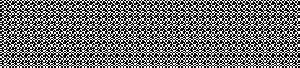

Relative volumes

Species stributions

Temperature data

Raw CPUE Trend

Longline configuration

CPUE by Hook

Gear deployment pattern

CPUE by Set

CPUE by Set and Depth

True and Sampled Abundance Trend

Population Abundance

Habitat Corrected Sets

Habitat Corrected Trend

SEEPA

Environmental Affinity

Gear (Feeding) Interaction

FSIM

Population Numbers

* Sex
* Age
* (Size)

**Figure 1**. Data relationships among the main components of the computer program (SEEPA) implementing the simulator. FSIM is a population simulator which is used to simulate the sex, size and age structure of the blue marlin population in time. It produces the time series of population abundances which are then distributed by latitude, longitude, depth and month by SEEPA.

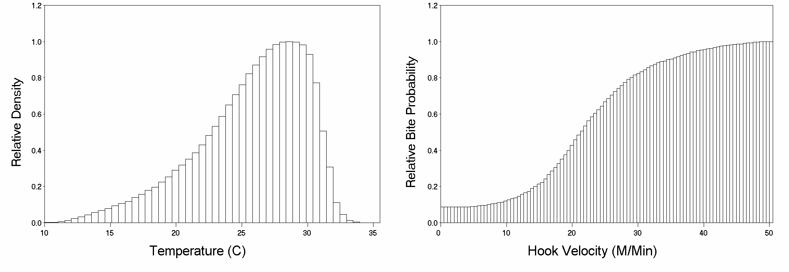

**Figure 2**. Sample temperature affinity file

**Figure 3**. Sample feeding interaction file.

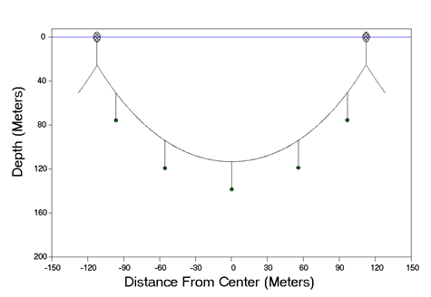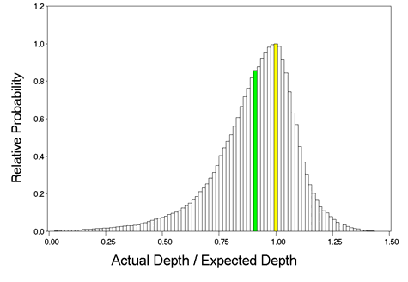

**Figure 4**. Sample hook depth distribution

at equilibrium assuming a catenary curve.

**Figure 5**. Sample distribution of hook depths

around the values predicted from a catenary

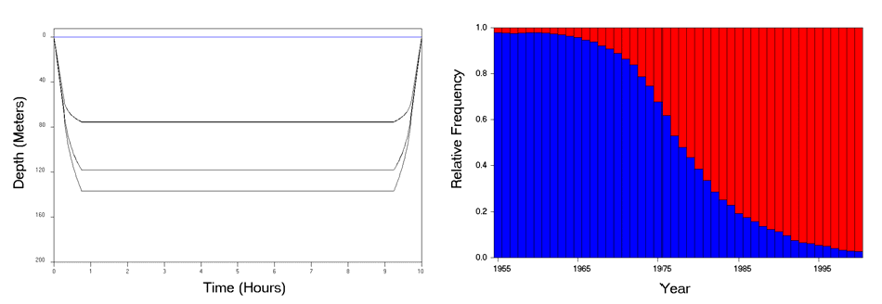

**Figure 6**. Example hook time at depth for a 5 hook per basket gear. Note that because of the symmetry hook 1 and 5 and hooks 2 and 4 overlap.

**Figure 7**. Example relative proportions of the total sets of each of two gears each year.

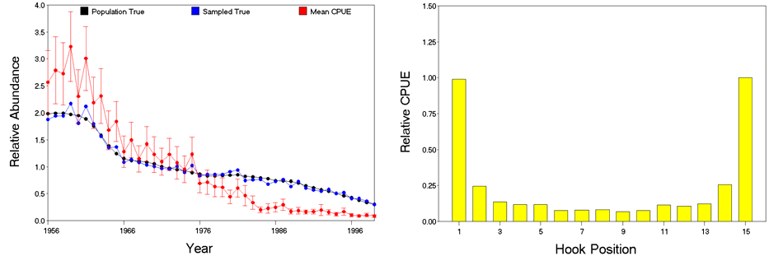

**Figure 8**. Sample unstandardized cpue trend

resulting from an assumed species and gear

distribution for a simulation.

**Figure 9**. Sample cpue by hook position

resulting from an assumed species and gear distribution for a simulation.

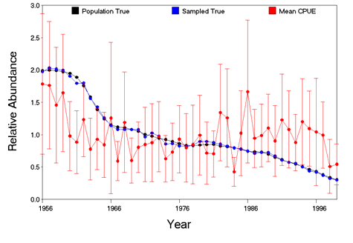

**Figure 10**. Sample habitat-standardized cpue trend resulting from an analysis that assumed a species and/or gear distribution different from those used to simulate the cpue data.